Data Structures & Algorithms
Lab 5: Implement BFS and DFS — Flood Relief Dispatch Network
Roll No: 2648555
Name: Sanjay R A

Aim
To represent a flood-hit road network as an adjacency list and implement Breadth-First Search (BFS) and Depth-First Search (DFS) in Python to plan dispatch waves, find the fewest-roads route from HQ to an urgent zone, find connected components and cut-off zones, and detect a loop (cycle) in the network.

Part A: Correctness & Demonstration

A.1 Source Code
Graph construction, BFS (levels and waves), fewest-roads route, DFS, connected components and cut-off zones (lines 1–94).
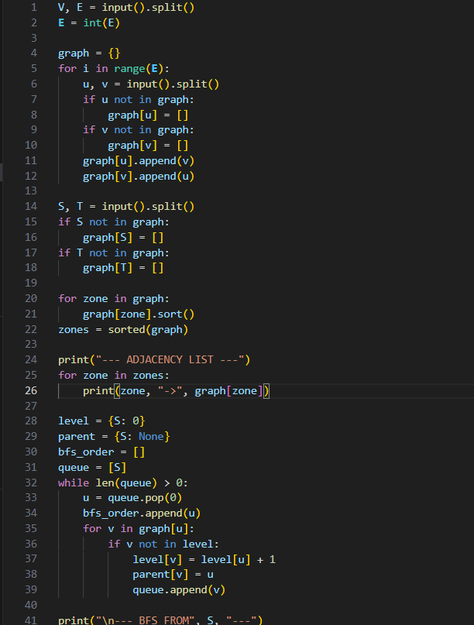
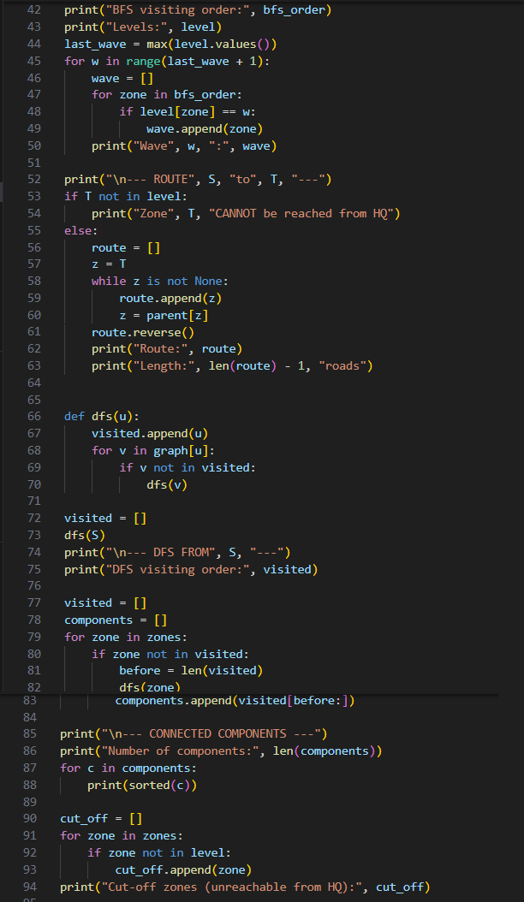

A.2 Input
Line 1 is V E (zones, roads); the next E lines are roads u v; the last line is S T (HQ, zone needing help). Sample data: HQ = A, target = G.
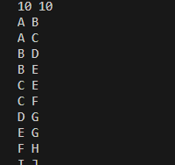

A.3 Output
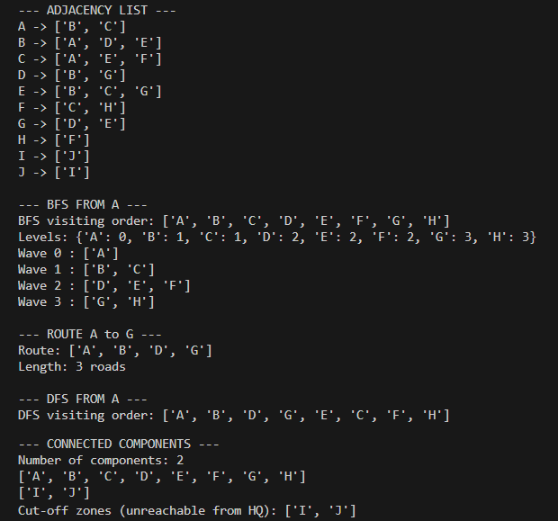

Part B: Self-Learning

B.1 Loop Detection: Source Code
DFS extended with the current path and the parent zone, so a neighbour already on the path (other than the parent) closes a cycle (lines 97–125).
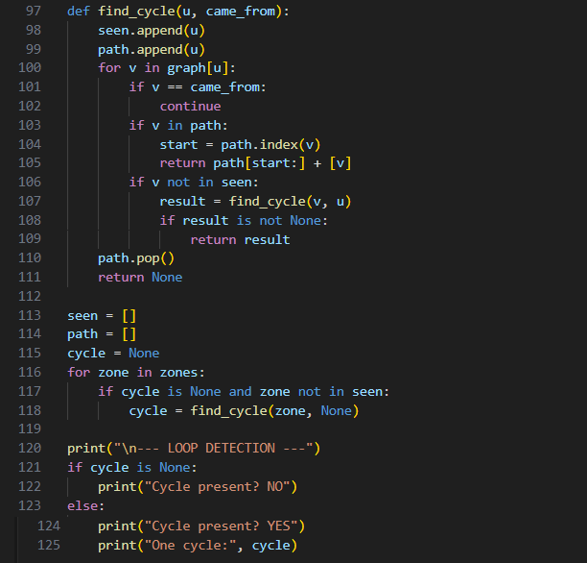

B.2 Input
Same sample input as Part A.

B.3 Output
The sample network contains a loop, so the program prints YES and one cycle: B → D → G → E → B.

B.4 Analysis Note
Complexity. With an adjacency list, both BFS and DFS visit every vertex once and examine every edge a constant number of times, so the time complexity is O(V + E). The space complexity is O(V) for the visited/level/parent structures plus the queue (BFS) or the recursion stack (DFS). With an adjacency matrix the time would rise to O(V²).
Why BFS gives the fewest roads but DFS does not. BFS explores the graph level by level, so a zone is first discovered through the smallest possible number of roads from HQ, and the parent pointer recorded at that moment lies on a shortest path. DFS follows one route as deep as it can before backtracking, so the first path it finds to a zone can be much longer than the shortest one.
AI/ML applications. BFS: shortest-path and state-space search in unweighted problems, and exploring a knowledge graph by hops from an entity. DFS: topological ordering of a computation graph for backpropagation, and depth-first search over game or planning trees.

